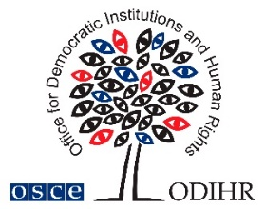
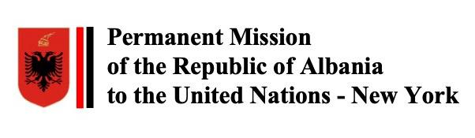

Concept Note
Side Event to the 70th Session of the Commission on the Status of Women (CSW 2026)

Gender equality laws:
An accelerator for equal participation and gender-responsive governance

When: 10 March 2026, 11:30-12:45
Where: United Nations Headquarters, Conference Room 8

Organised by:
Albania & the OSCE Office for Democratic Institutions and Human Rights (ODIHR), in partnership with Poland

Gender equality laws can be powerful accelerators for equal representation of women and men and gender-responsive governance when they move beyond general principles and create enforceable duties that change how public decisions are made: who participates in decision making, how policies are designed, how budgets are prepared, how services are delivered and how results are monitored. The strongest laws typically combine:

- Enforceable representation obligations for elected and appointed decision-making bodies at national and local levels;
- Legally grounded gender mainstreaming duties and tools across the policy cycle and decision making, including gender impact assessment, inclusive public consultations, gender-responsive budgeting, gender audit, etc; and
- Accountability arrangements that make compliance real, including clear mandates for institutional mechanisms for gender equality, monitoring and evaluation clauses, as well as reporting duties, sex-disaggregated data requirements, and accessible, effective, proportionate and dissuasive remedies.

In this context, the OSCE Office for Democratic Institutions and Human Rights (ODIHR) offers practical reference points for “how law becomes delivery”. First, its Comparative Note on Gender Equality Laws in the OSCE region elaborates extensively on good and existing practices. Second, its Gender-responsive Governance Toolkit offers targeted tools that introduce institutional and policy solutions for gender-responsive governance for democratic institutions, including parliaments and political parties. Third, its guide on Institutional Mechanisms as Critical Actors for Gender Equality provides an overview of gender mainstreaming practices in the OSCE region and explains why well-mandated and adequately resourced governmental bodies are pivotal for implementation, co-ordination across government, sustained political attention, and accountability for results. Finally, ODIHR Guidelines on Democratic Lawmaking for Better Laws that, among other, provide concrete recommendations on how to mainstream gender and diversity throughout the legislative cycle.

Albania’s new Law on Gender Equality, adopted on 7 November 2025, provides a timely and practical anchor for the discussion. The law strengthens obligations for public institutions and introduces representation thresholds, requiring that no gender holds less than 30 per cent of positions, with a longer-term goal of approaching 50 per cent representation. The side event will use Albania’s reform to explore which legal design choices most effectively translate gender equality commitments into measurable change in parliaments, governments and local authorities, and how legal obligations can strengthen gender-responsive governance in day-to-day policy-making and budgeting.

To complement Albania’s experience, the side event will draw short, targeted lessons from additional reference points on existing practices.

Objectives
- Identify solutions that most effectively accelerate equal representation in elected and appointed decision-making at national and local levels, and the compliance and enforcement features that make these provisions effective in practice.
- Explore how gender equality laws can embed gender-responsive governance across the full policy, legislative and budget cycle through gender mainstreaming duties, institutional mandates, and reporting and data requirements, including how these obligations can be operationalised in public administration and local government.
- Distil implementation lessons on what enables laws to deliver results, with a focus on the roles of institutional mechanisms for gender equality, inter-institutional co-ordination, capacity, monitoring, remedies and accountability, and identify avenues for reforms of existing gender equality laws.

Audience
Member State delegations, parliamentarians, human rights organizations, women’s rights groups, academia.

Registration
No registration is needed, but seating is limited to 96 people.

Contact
For further information, please contact the OSCE Office for Democratic Institutions and Human Rights (Sasa.Gavric@odihr.pl) for additional details.

Side Event to the 70th Session of the Commission on the Status of Women (CSW 2026)

Gender equality laws:
An accelerator for equal participation and gender-responsive governance

When: 10 March 2026, 11:30-12:45
Where: United Nations Headquarters, Conference Room 8

Organised by:
Albania & the OSCE Office for Democratic Institutions and Human Rights (ODIHR), in partnership with Poland

Moderator:
Yulia Netesova, Chief of Democratic Governance and Gender Unit, ODIHR

Introduction by the moderator and opening remarks

Evis Sala, Minister of Health and Social Welfare, Albania
Tea Jaliashvili, First Deputy Director, OSCE ODIHR

Panel

- Marianne Mikko, Vice Chair of the CEDAW Committee: gender equality laws as a tool to localise CEDAW standards
- Saša Gavrić, Adviser on Gender Issues, ODIHR: the role of governmental bodies for gender equality
- Liesbet Stevens, Deputy Director, Institute for the Equality of Women and Men, Belgium: the importance of legally grounded gender mainstreaming duties and reporting
- Shoko Ishikawa, Deputy Director, Policy, Programme and Intergovernmental Division, UN Women: gender-responsive budgeting regulation

Interventions by Member State delegations and interactive Q&A

Closing remarks
Magdalena Dropek, Deputy Director of the Department for Equal Treatment
Chancellery of the Prime Minister, Poland

