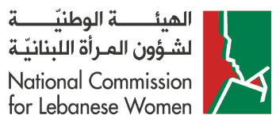
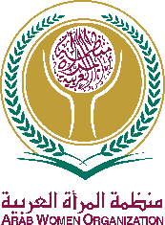
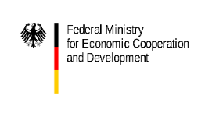
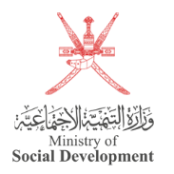
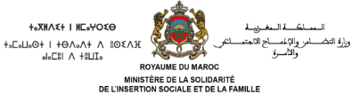
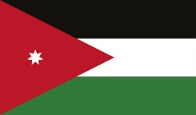
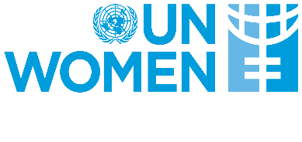

Concept Note

Side Event at the 68th Session of the Commission on the Status of Women (CSW68)
Date: Tuesday 12 March 2024
Venue: Conference Room 12 – General Assembly Building
Time: 3:00 pm – 4:15 pm

Title: "The Care Economy in an Evolving World:
Equal Sharing of Caregiving and Household Responsibilities between
Men and Women as Tool for Social Equity and Cohesion"
Organized by Lebanon, the Arab Women Organization and UN Women
in cooperation with Egypt, Germany, Jordan, Morocco, Oman, Spain and Sweden

Background:
Strengthening the care economy -including through the involvement of men and boys in unpaid care and domestic work- is fundamental to reduce poverty of women and girls and improve financing to gender equality. In light of the International Day of Care and Support, recently established by the United Nations General Assembly on 29 October and observed for the first time in 2023, increasing global attention has been given to the need of investing in the care economy and to create robust and gender-responsive care systems. The UN General Assembly proclaimed this day to call upon UN Member States, the UN system, civil society, the private sector, academia, and the public to promote efforts to recognize, reduce, value and redistribute unpaid care and domestic work.
The Arab and Mediterranean region faces many changes that are threatening social equity and cohesion, including within the family, which is considered as a fundamental social institution to support stability, safety, and nurturing for all its members. Nowadays, we can observe some changes in family roles to respond to contextual challenges, which reflect the capacity for adaptation and resilience of families and their members. The global economic hardships are currently putting pressure on families and societies, urging both men and women to contribute to income generation and share economic and social responsibilities; thus, inevitably, the unpaid care and domestic work needs to be shared as well. It is not justified to maintain discriminatory gender roles within the families that disadvantage women and girls. In the families of today, men and women, boys and girls, should share these responsibilities as they share others.
Official data documented by UN Women indicates that women spend around three times as many hours on unpaid care work as men. This gap continues to be large in the Arab region, where women are still performing many more hours than men in unpaid care work: between 17 and 34 hours per week, compared to only between 1 to 5 hours per week invested by men, depending on the country.
How can we ensure active male participation in the essential care economy that societies require? One viable solution is to prioritize the acknowledgment of care and domestic work, making it accessible within the labor market to attract individuals—including—seeking employment opportunities. There exists a substantial societal demand to address caregiving responsibilities and alleviate the disproportionate burden placed on women and girls. Meeting these needs necessitates a comprehensive, whole-of-society approach to the care economy, involving coordinated interventions and support from the government, private sector, and other stakeholders.
What about the role of men and boys—whether as husbands, fathers, brothers, or sons—in unpaid care and domestic work? The significance of men's involvement in tackling the structural barriers and disproportionate burden of unpaid care and domestic work on women and girls cannot be overstated. Global evidence, including insights from the Arab region, underscores that men's engagement in caregiving and the equitable sharing of household responsibilities between males and females are crucial for fostering healthy and thriving families, communities, and societies. Moreover, such involvement stands as a fundamental contributor to realizing substantive gender equality and empowering women.
Despite the progress made by numerous countries, substantial efforts are still required to acknowledge and fortify the care economy while diminishing gender inequalities in unpaid caregiving globally, including in the Arab and Mediterranean region. The engagement of men and boys is paramount in rectifying these imbalances in unpaid care work and enhancing the well-being of individuals and families across the board.

Objectives of Side Event:
- Overview of some major transformation in roles within families and the increasing need to address caregiving of children, the elderly and other social groups.
- Present global and regional evidence on how positive masculinities and the involvement of men and boys in caregiving benefit individuals, families, communities and societies at-large.
- Promote the exchange of knowledge and sharing of good practices and innovative tools, vision and future plans among key high-level representatives and participants on the involvement of men in caregiving and its contribution to further promote gender equality and women’s empowerment.
- Discuss challenges and opportunities in countries from the Arab and Mediterranean region to promote positive masculinities, men’s involvement in childcare and paternity leave.
- Identify common ground and joint actions to promote the involvement of men and boys in caregiving across the Arab and Mediterranean region.

Proposed Agenda and Speakers:
Time | Agenda Item and Speakers | Duration
15:00 | Welcome and opening remarks:  - H.E. Claudine Aoun, President of the National Commission for Lebanese Women, Republic of Lebanon; and Member of the Supreme Council, Arab Women Organization  - H.E. Dr. Fadia Kiwan, Director General, Arab Women Organization | 10 min  (5 min for each speaker)
15:10 | Keynote interventions:  - H.E. Dr. Maya Morsi, President of the National Council for Women, Arab Republic of Egypt; and President of the Supreme Council, Arab Women Organization  - H.E. Wafa Bani Mustafa, Minister of Social Development and Chair of the Inter-Ministerial Committee for Women’s Empowerment, Hashemite Kingdom of Jordan  - H.E. Aawatif Hayar, Minister of Solidarity, Social Integration and Family, Kingdom of Morocco; and Member of the Executive Council, Arab Women Organization  - H.E. Ana Redondo García, Minister of Equality, Spain  - H.E. Paulina Brandberg, Minister for Gender Equality and Working Life, Sweden  - H.E. Dr. Sima Sami Bahous, UN Women Executive Director, and United Nations Under-Secretary-General  - H.E. Svenja Schulze, Minister of Economic Cooperation and Development, Federal Republic of Germany (video intervention)  - H.E. Al-Sayeda Maani bin Hamad Al Busaidi, Director General of Family Development, Ministry of Social Development, Sultanate of Oman; and Member of the Executive Council of the Arab Women Organization (video intervention) | 45 min  (5 min for each speaker)
15:55 | Discussion/Q&A session  (Moderator: Rodrigo Montero Cano, Regional Programme Manager, UN Women Regional Office for the Arab States) | 15 min
16:10 | Closing remarks  - H.E. Wafaa Dikah Hamze, President of the Executive Council of the Arab Women Organization from the Republic of Lebanon | 5 min
[Note: Simultaneous interpretation in English/Arabic/French/Spanish will be available during the event.]

From the conclusions of the Arab Women Organization’s workshop on Transformative Social Roles Towards Maternity and Childcare held on 17-18 October 2022.
UN Women. (2020). Whose time to care? Unpaid care and domestic work during COVID-19. UN Women.
UN Women (2020). The Role of the Care Economy in Promoting Gender Equality: Progress of Women in the Arab States 2020. Available online here.
This includes the care of babies and children, of persons with disabilities, with illnesses, and the elderly
Namely: the State of the World’s Fathers reports (2023, 2021 and 2019); the International Men and Gender Equality Survey (IMAGES) conducted in Egypt, Lebanon, Morocco and Palestine (2017); IMAGES Tunisia (2022); and IMAGES Jordan (2022).
Participation of high-level keynote speakers is in alphabetical order according to the name of the country, with priority to speakers participating physically at the side event.

